Protocols for Bio-optical Measurements

on the R/V Mirai

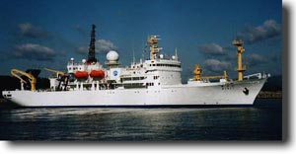

Overall Sampling Strategy (Please read first)
- Photosynthesis-Irradiance experiments (PI’s)
- Samples collected for HPLC pigment determinations
- Measurements of Turner fluorometry
- Measurements of phytoplankton absorption
- Creating a data CD-ROM
- Measurements of Coloured Dissolved Organic Matter (CDOM)
- Samples collected for flow cytometry (picoplankton)
- Measurements with the SIMBAD radiometer
- MarRefFile
- SIMBAD log sheet
- Example of a sun file
- Example of a dark file
- Example of a sea file
- Measurements with the SIMBADA radiometer
- SIMBADA log sheet
- Measurements with the hand-held spectral radiometer
- Continuous measurements with the PAR sensor

Selected Participants

 | 
Partnership for Observation  of the Global Oceans | International Ocean-Colour  Coordinating Group

